EVS Placement description

BOSNIAN REPRESENTATIVE ASSOCIATION FOR VALUABLE OPPORTUNITIES (BRAVO)

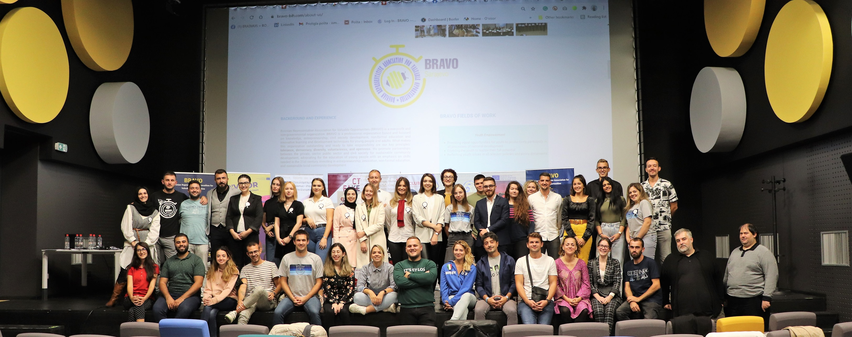Bosnia and Herzegovina

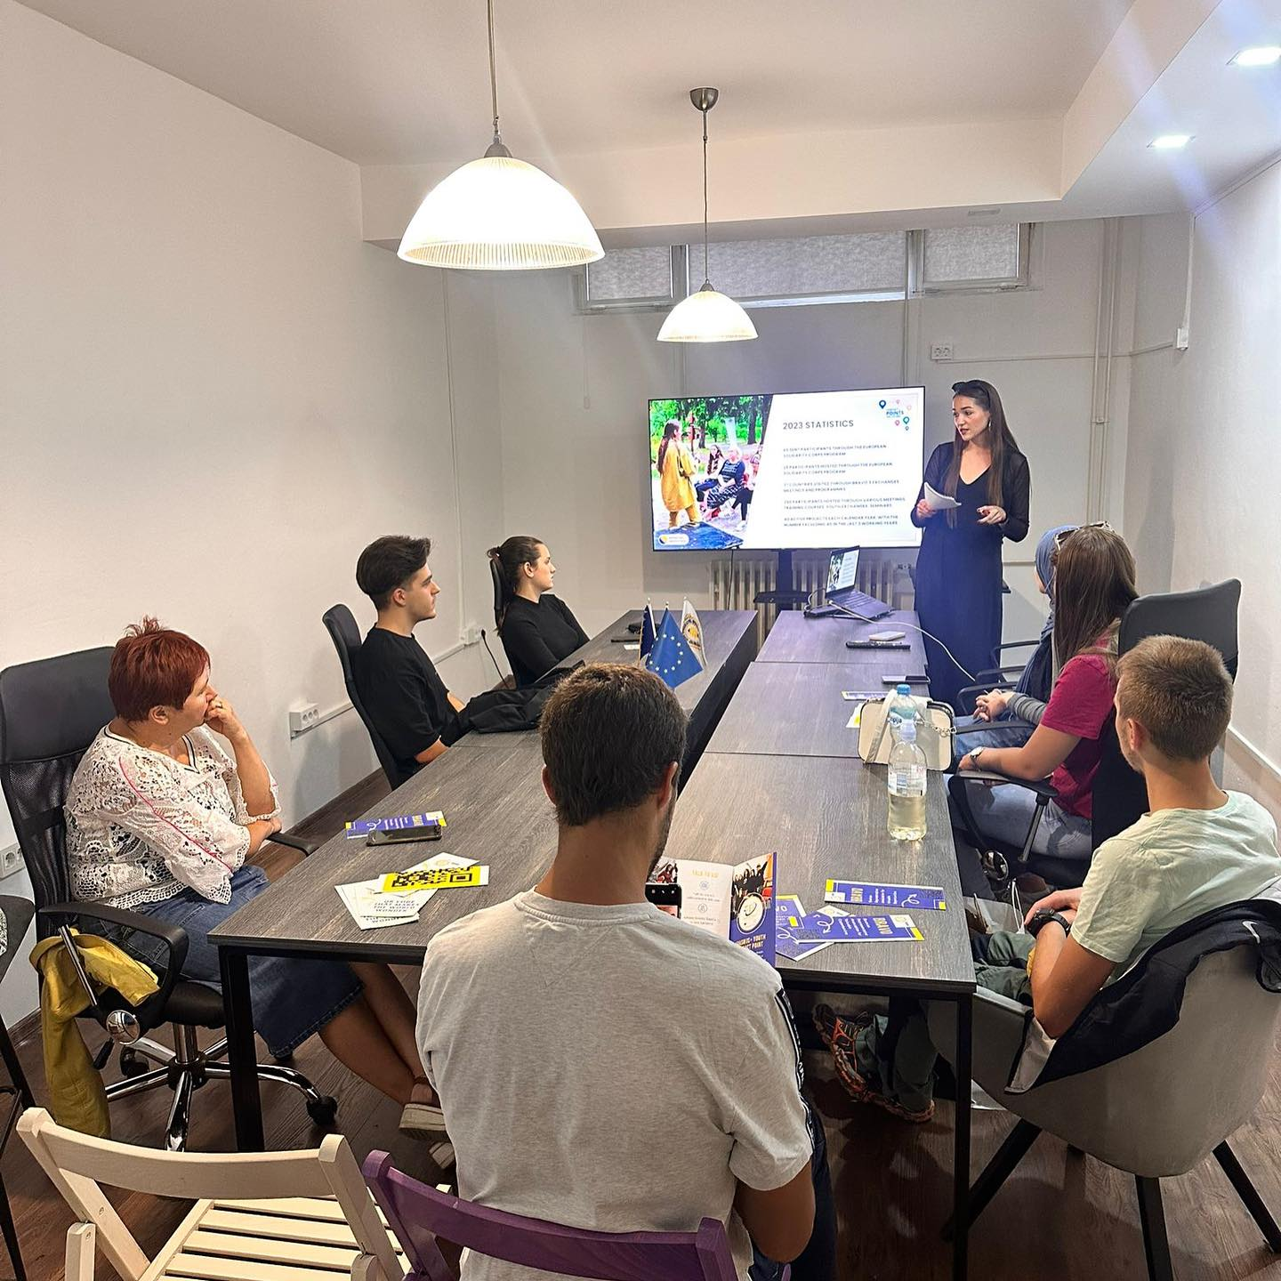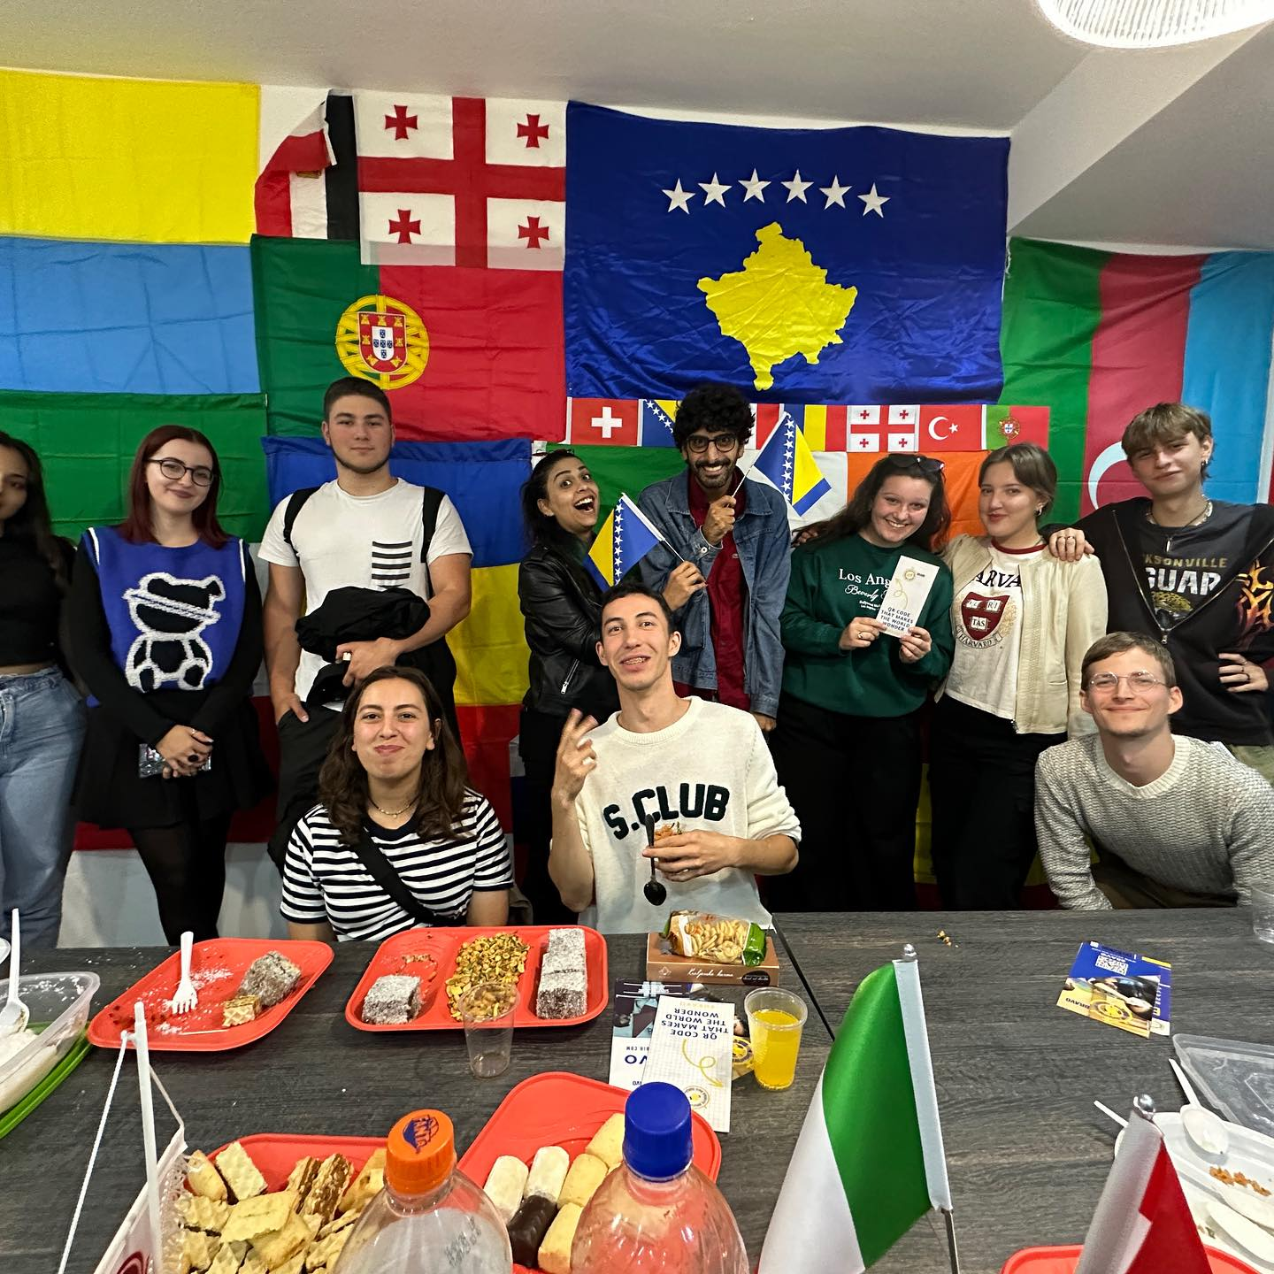

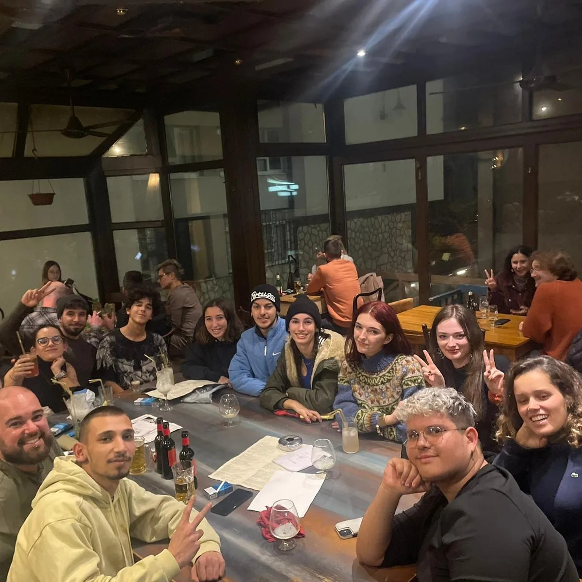

Information about the hosting organization

Description of the organisation

Bosnian Representative Association for Valuable Opportunities (BRAVO) is a non-governmental organization that prioritizes knowledge, entrepreneurship, civil society development, non-formal education, and innovative learning and development techniques for young people and adults. BRAVO's key principles are tolerance, democracy, diversity, voluntariness, and openness, which guide the organization's actions.

BRAVO is a leading organization in Bosnia and Herzegovina that serves as the Contact Point for Erasmus+ Youth. As such, it plays a crucial role in facilitating and supporting the participation of Bosnian youth in various Erasmus+ youth programs.

Additionally, BRAVO has been recognized for its outstanding humanitarian work and has received the ESC Humanitarian Aid Quality Label, making it one of only 100 organizations in the world to have earned this prestigious accreditation. Furthermore, BRAVO has also been awarded the Quality Label for European Solidarity Corps, which attests to its commitment to excellence in the area of solidarity and volunteering.

BRAVO's expertise extends beyond youth development and humanitarian work. It is the only organization in the Western Balkans region that has the authority to certify companies and individuals on digital skills and competencies. This certification program is designed to equip individuals and organizations with the skills they need to thrive in today's digital landscape.

Overall, BRAVO is an organization committed to driving positive change in Bosnia and Herzegovina and beyond. Its focus on youth development, humanitarian aid, and digital skills training, along with its numerous accreditations and certifications, makes it a highly respected and effective organization in the region.

BRAVO fosters partnerships between the private, public, and civil society sectors, enabling it to contribute to long-term local community development. Its focus is on empowering youth to gain the skills necessary for the 21st century, offering more accessible and inclusive non-formal education, and investing in innovations and entrepreneurship. BRAVO targets young people aged 15 to 35, but it is also committed to assisting individuals of all ages in need of support.

BRAVO concentrates on worldwide initiatives that uphold European values and ideals, particularly working with individuals who have less access to opportunities. The organization collaborates with institutions and organizations that support people with disabilities, organizing sign language courses and sports activities for individuals who are blind or have impaired vision. BRAVO engages participants from across Europe to volunteer and learn about ways to support vulnerable groups.

BRAVO's team operates in various fields and topics, including human rights, anti-trafficking, reproductive health and STDs, gender equality and combating gender-based violence, sports, audio and video production, people with fewer opportunities, event organization, entrepreneurship, IT and ICT, technology, humanitarian actions, national and international projects, support in the fight against criminality and corruption, accelerating start-ups, industry 4.0, project management, refugee and migrant support, and creative actions. The organization is also involved in publishing books, brochures, newsletters, flyers, affiliations, and other publications.

Website

For further details, visit <https://bravo-bih.com/>

Language of the hosting organization

Bosnian, English

Information about the EVS Placement

|  |  |
| --- | --- |
| Duration (in months): | 3 months |
| Start Date | April/June 2024 |
| End Date | June/August 2024 |

Activity description

* Within the scope of the project, a total of 2 volunteers will be hosted, for the period of two months.
* Within the scope of the project, volunteers will actively work and participate in following activities:

1. Human rights and equality, active citizenship awareness campaigns and local workshops;
2. Supporting young people and children with special needs;
3. Protecting the environment and raising environmental awareness;
4. Supporting and doing sport activities with sport trainers and sportsman; and
5. Other youth work activities will be carried out.

Volunteer’s profile

Teamplayer;

Able to adapt to flexible working hours;

Able to stay in shared homes;

No travel barrier;

Ages of 18-30;

Aware of social responsibility;

Able to work with disabled individuals and children;

Have sportive skills;  
Speaks English;

Practical arrangements

Accommodation costs will be fully covered. Volunteers will stay in shared house with single rooms. Food will be also covered. Local transportation support will be provided and also local SIM card will be provided for volunteers. All of our ESC volunteers will have accommodation in city centre with their own space. Living room, kitchen and bathrooms will be shared.

Funding

Movetia’s funding for the EVS programme covers:

* Board and lodging
* International travel costs (400CHF)
* Pocket money (?CHF per day)
* EVS Trainings

How to apply

Send your application to [office@bravo-bih.com](mailto:office@bravo-bih.com) (ref: EVS Placement BRAVO 2024) as soon as possible with:

* a CV, and
* a Motivation Letter.

For more information, you can contact:

**Mr. Ismail Šehić (email:** [**i.sehic@bravo-bih.com**](mailto:i.sehic@bravo-bih.com) **and** [**office@bravo-bih.com**](mailto:office@bravo-bih.com)**)**